**AWS Networking**

A Network is a way of communication between devices. AWS Networking allows creating a fast, reliable, and secure network. [AWS offers various cloud services](https://k21academy.com/aws-training-courses/) that are on-demand, available, and highly scalable. Various AWS services make an AWS network complete, like Amazon VPC, Amazon EC2, [Amazon Route 53](https://k21academy.com/amazon-web-services/aws-solutions-architect/aws-route-53/), Load Balancers, Amazon Gateway, and more. All the services individually create an Amazon Network.

## Amazon VPC

Amazon VPC or Virtual Private Cloud is a service that allows us to create an isolated virtual network for our Amazon resources. A virtual network is a private network that is always hidden from the outside world, and you can perform certain operations that you don’t want to make public. Any user with their AWS account can host Amazon VPC. You can create, access, and manage Amazon VPC with the help of certain tools and services like the Amazon Web Service Management Console, Amazon CLI (Command Line Interface), Amazon SDK, and Query API.

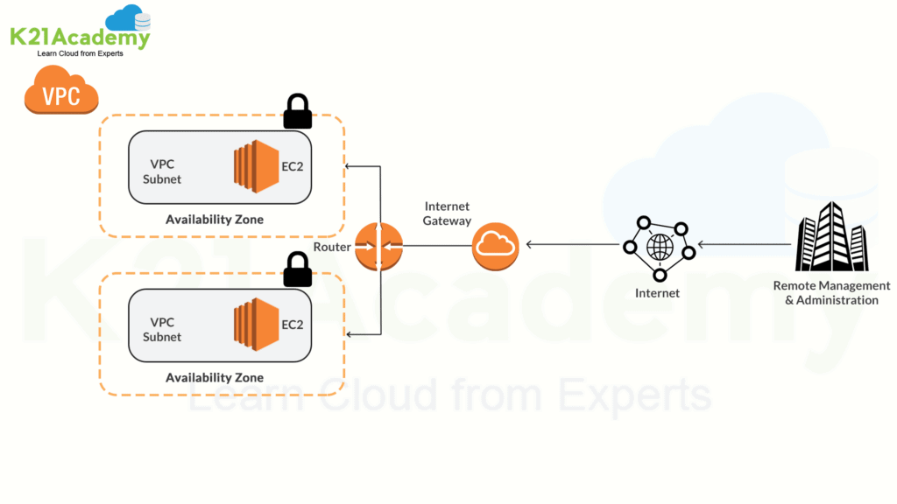

## Virtual Private Cloud (VPC)

Amazon Virtual Private Cloud ([Amazon VPC](https://k21academy.com/amazon-web-services/aws-vpc-virtual-private-cloud/)) is a service that lets you launch AWS resources in a logically isolated virtual network that you define. You can use both IPv4 and IPv6 for most resources in your virtual private cloud, helping to ensure secure and easy access to resources and applications.

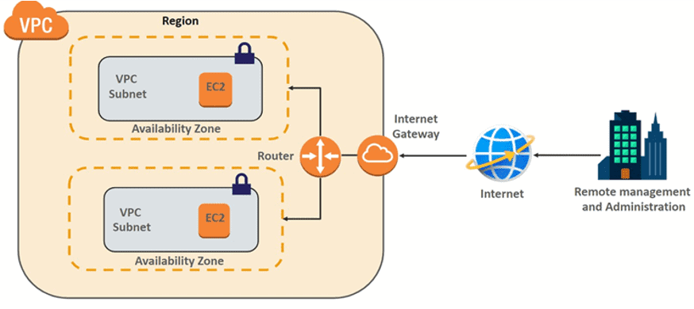

**What are the Benefits Of Using AWS Virtual Private Cloud?**

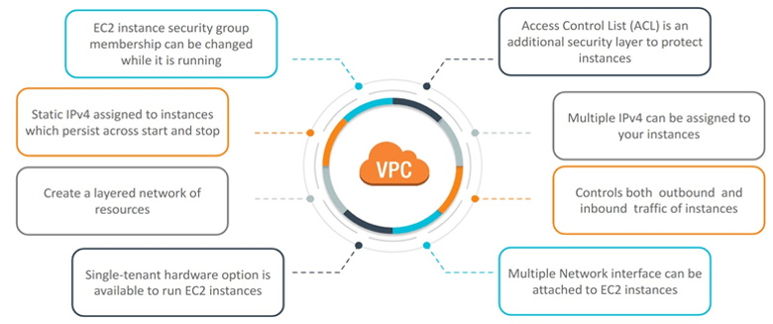

**What is the Component Of VPC?  
Ans.**Following are the components of a Virtual Private Cloud (VPC)

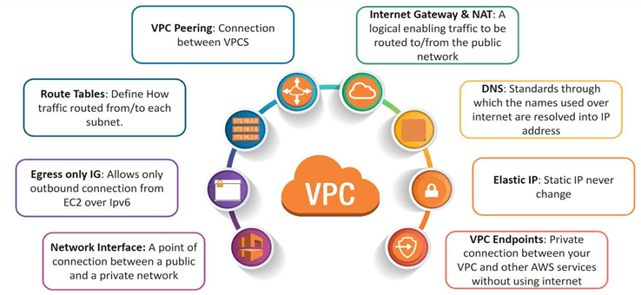

**What Is A Subnet?**

**A subnetwork** or subnet is **a logical subdivision of an IP network**. The practice of dividing a network into two or more networks is called subnetting. AWS provides two types of subnetting: public, which allows the Internet to access the machine, and private, which is hidden from the Internet.

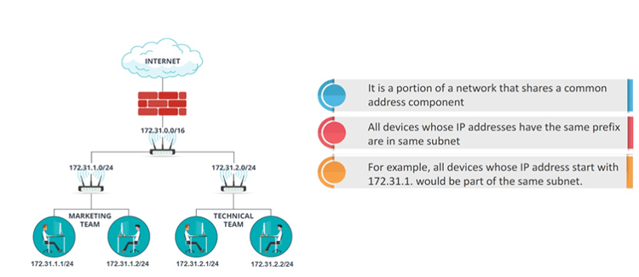

### ****Some Basic Concepts for Amazon VPC****

* **Subnet** – A subpart of your network with a dedicated range of IP addresses.
* **Route Table** – It is used to direct traffic with a set of rules called routes.
* **Gateway** – It enables communication between your network and resources.

## Network Address Translation (NAT)

Network Address Translation (NAT) is designed for IP address conservation. It enables private IP networks that use unregistered IP addresses to connect to the Internet. This provides additional security by effectively hiding the entire internal network behind that address.

## There are two types of NAT Devices in AWS

## NAT

## Virtual Private Network (VPN)

Virtual Private Network solutions establish secure connections between your on-premises networks, remote offices, client devices, and the AWS global network. AWS Site-to-Site VPN **creates encrypted tunnels between your network and your Amazon Virtual Private Clouds or AWS Transit Gateways.**

## VPN

## CloudWatch

Amazon CloudWatch is a monitoring and management service that provides data and actionable insights for AWS, hybrid, and on-premises applications and infrastructure resources. With CloudWatch, you can collect and access all your performance and operational data in the form of logs and metrics from a single platform.

## CloudWatch

## Load Balancer

A load balancer accepts incoming traffic from clients and routes requests to its registered targets (such as EC2 instances) in one or more Availability Zones. The load balancer also monitors the health of its registered targets and ensures that it routes traffic only to healthy targets.

## Load Balancer

## What are the types of load balancers in AWS?

## Load Balancer

## What are the Benefits of Load Balancer?

## Load Balancer

## AWS Global Accelerator

AWS Global Accelerator is a networking service that improves the performance of your users’ traffic by up to 60% using Amazon Web Services’ global network infrastructure. AWS Global Accelerator uses the**vast, congestion-free AWS global network to route TCP and UDP traffic to a healthy application endpoint in the closest AWS Region to the user**. If there’s an application failure, AWS Global Accelerator provides instant failover to the next best endpoint.

## Load Balancer

## Auto-Scaling

AWS Auto Scaling lets you build scaling plans that automate how groups of different resources respond to changes in demand. You can optimize availability, costs, or a balance of both. AWS Auto Scaling automatically creates all of the scaling policies and sets targets for you based on your preference.

## Auto Scaling

## AWS Route 53

Amazon [Route 53](https://k21academy.com/amazon-web-services/aws-solutions-architect/aws-route-53/) is a highly available and scalable cloud Domain Name System (DNS) web service. It is designed to give developers and businesses an extremely reliable and cost-effective way to route end users to Internet applications by translating names like www.example.com into the numeric IP addresses like 192.0.2. that computers use to connect to each other. Amazon Route 53 is fully compliant with IPv6 as well.

## image

## What are the various Routing Policies in Route 53?

## Load Balancer

## Amazon EC2

Amazon Elastic Compute Cloud or EC2 is one of the most used AWS services to create and launch virtual machine instances. It provides a secure and resizable compute capacity in the cloud. It helps create various virtual machines instances within the cloud that can be easily set up in a while. For Amazon Networking, Amazon EC2 is one of the key services.

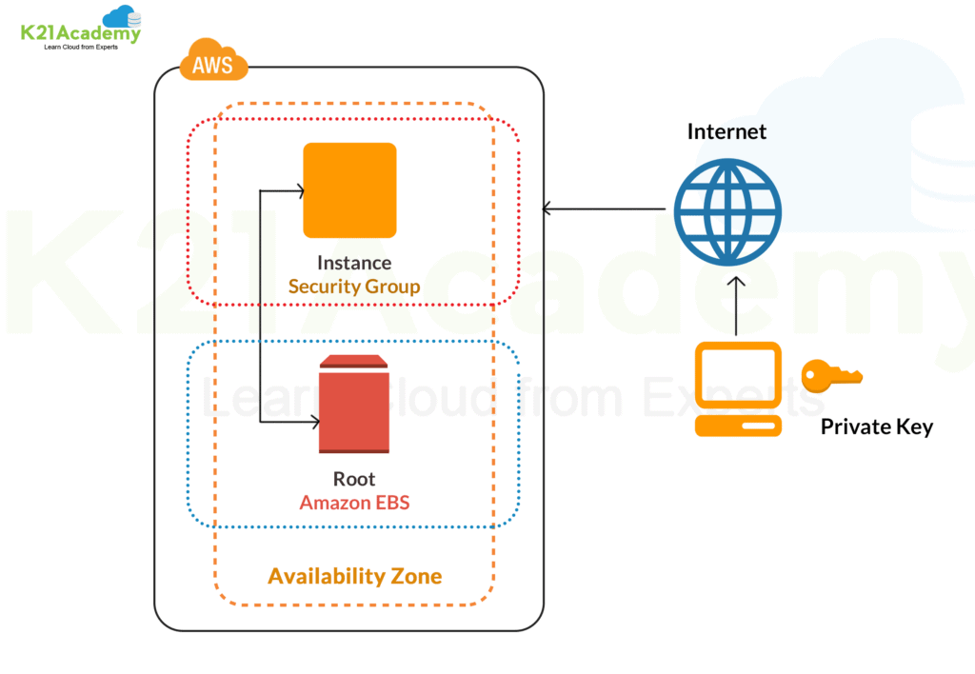

### Key Features of Amazon EC2 Instance

* Uses predefined and preconfigured Amazon Machine Images (AMI) for easy setup.
* It allows you to configure memory, storage, and networking capacity for the instance based on your need.
* AWS EC2 instance is secured with key pairs for storing login information.
* Uses a secure firewall to specify IP, range, ports, and protocols to access your instance.
* Uses Instance Store Volumes to preserve your temporary data if you stop, hibernate, or terminate the instance.

## Amazon Route 53

Amazon Route 53 is a scalable and highly available Domain Name System (DNS) service. It enables to route end users to internet applications reliably and cost-effectively. Route 53 connects user requests infrastructure inside or outside of AWS Infrastructure, including Amazon EC2 instances, Elastic Load Balancers, Amazon S3 buckets, and more.

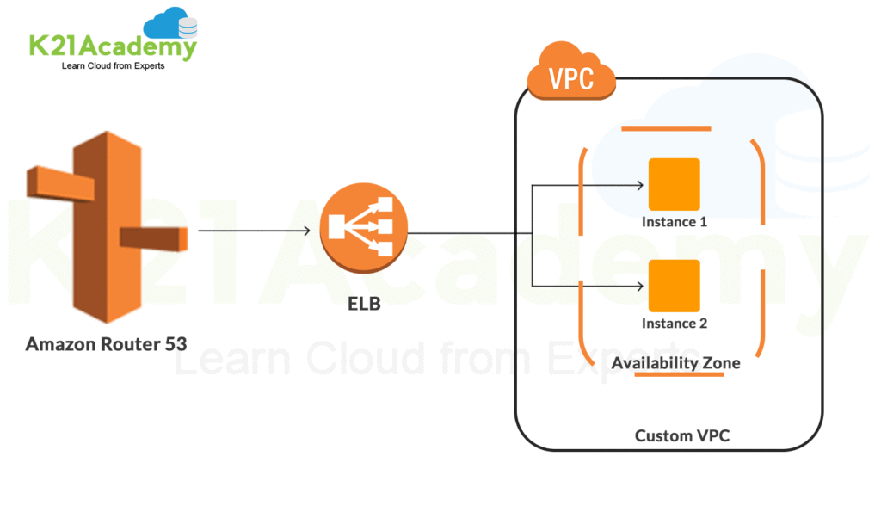

### ****Key Benefits of Amazon Route 53****

* **Highly Available and Reliable** – In case of failover Amazon Route 53 Traffic Flow routs users to an alternate location if the primary location is unavailable.
* **Flexible and Fast** – A user can create and edit traffic policies. Also, depending on network conditions, it routes users to optimal locations.
* **Simple and Secure** – You can configure DNS settings using AWS Management Console or an easy-to-use API. Also, by integrating Amazon Route 53 with [IAM](https://k21academy.com/amazon-web-services/aws-solutions-architect/aws-identity-and-access-management-iam/) (Identity Access Management), you can create and manage permissions for each user with unique credentials.
* **Scalable and Cost-Effective**– Route 53 can handle large query volumes by auto-scaling. Also, your charges for Route 53 depend on the resources and the number of queries.

## Amazon Load Balancing

Elastic Load Balancing is a load balancing service for AWS. It helps in automatically distributing incoming traffic from various cloud applications and scaling resources to meet the traffic demands. It works over various resources like Amazon EC2 instances, containers, IP addresses, and lambda functions.

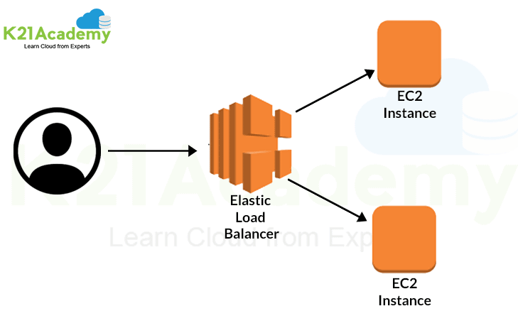

### ****Key Features of Amazon Load Balancing****

* **High Availability** – It is a fully managed service and provides high availability by keeping your applications available across a region without the need for GSLB (Global Server Load Balancing).
* **Security** – It provides robust security features like integrated certificate management, SSL/TLS decryption, and user authentication.
* **Robust Monitoring** – It allows you to monitor the performance and health of your applications in real-time with the help of Amazon Cloud Watch metrics, logging, and tracing.

### ****Types of Load Balancers****

* Application Load Balancer
* Network Load Balancer
* Gateway Load Balancer
* Classic Load Balancer

## AWS Private Link

AWS Private Link provides private connectivity between various amazon services. The connectivity is done between Amazon VPC (Virtual Private Cloud), Amazon Web Services, and on-premises network without exposing traffic to the public internet.

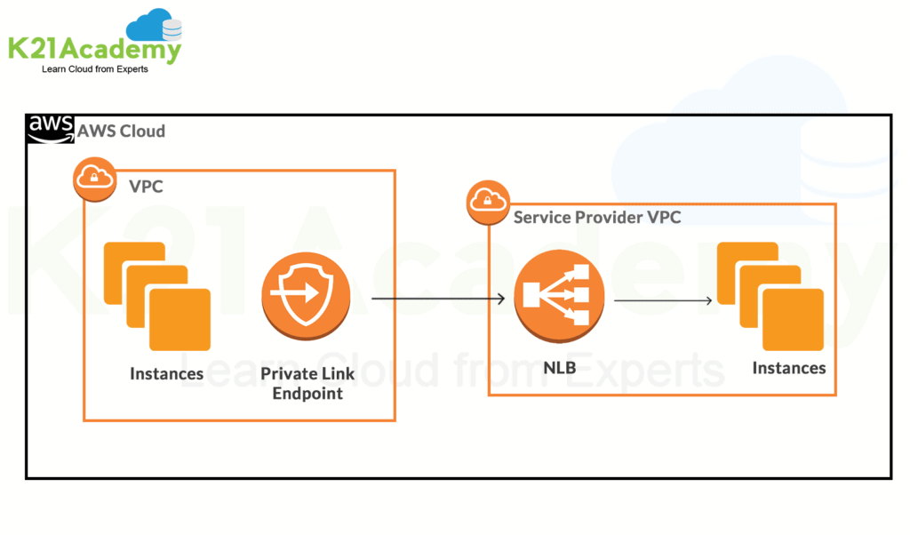

### Features of Private Link

* **Secure Traffic** – It reduces exposure to various threats like brute force and distributed DOS attacks as it doesn’t traverse the public internet.
* **Simplicity** – It allows to connect with services across Amazon VPC without the need for firewall rules, path definitions, or route tables.

## AWS Direct Connect

AWS Direct Connect helps in establishing a dedicated network from your premises to AWS. It enables a private and secure connection between AWS and the data center. It is compatible with AWS services and supports a high bandwidth for a more consistent network and better speed. The starting speed is around 50 Mbps and supports scaling up to 100 Gbps.

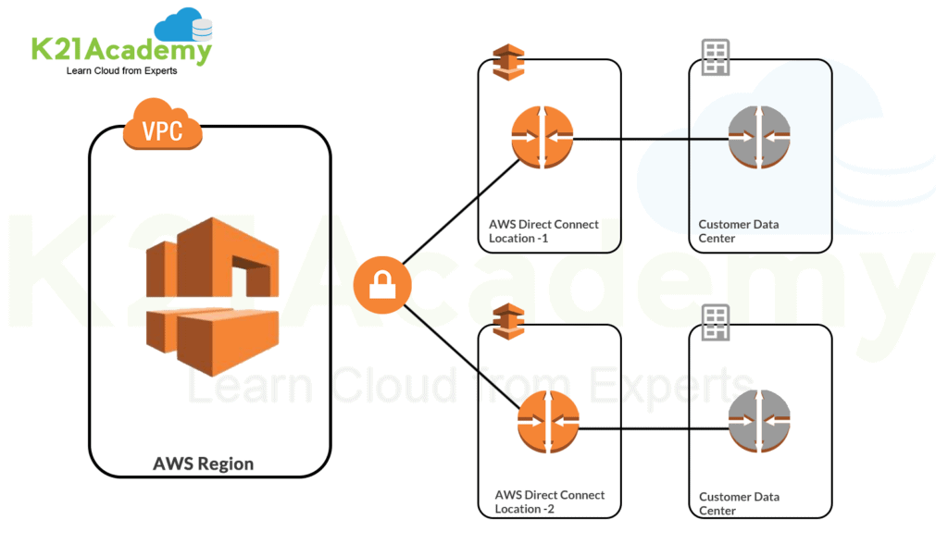

### Key Components of Direct Connect

* **Connections** – Connections are created for the communication between AWS and on-premises.
* **Virtual Interfaces** – It enables access to AWS services. Public interface access public services like Amazon S3, whereas a private interface access private services like VPC (Virtual Private Cloud).

## Amazon Gateway

Gateway is a service that acts as a gatekeeper for your network. All the request goes that is made from one end goes through a gateway to reach the other end. In simple words, it joins two networks for enabling communication between the devices present in them. For Amazon Networking, two common Amazon Gateways are used **API Gateway** and **Transit Gateway**.

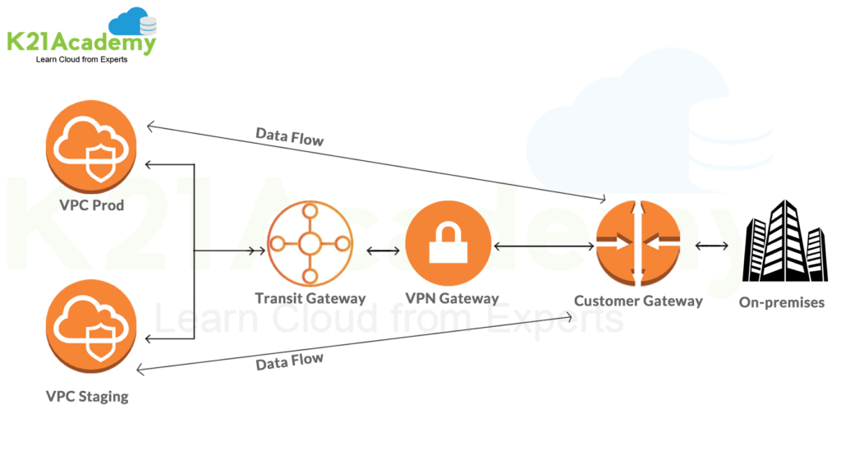

* **Transit Gateway** – Simplifies network and peering relationships by connecting VPC and on-premises networks through a central hub.
* **API Gateway –** It handles all the tasks to accept and process all the API calls. It helps developers to create, publish, monitor, and secure API at any scale.

## AWS Network Architecture

AWS Network architecture is a representation or structured way for connecting various AWS services in a cloud. It serves the connectivity needs by creating a web of interconnected devices. Using the various AWS components and services, a fast and secured network is created.

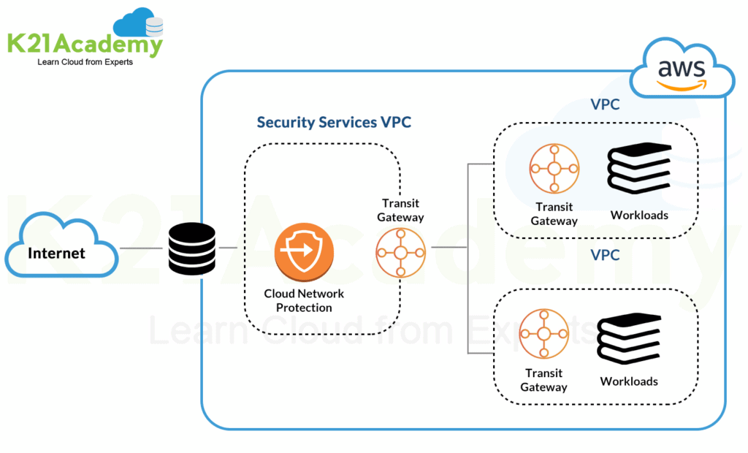

The above diagram shows a sample of AWS Networking Architecture with Amazon VPC, where multiple components and services are connected to create a network.